# Experiment No-10

**NAME - Jagdish Padale**

**TE ENTC 39**

**TITLE- SimulationStudyof LinearBlockCodes.**

**INPUT:**

%SimulationStudyofBlockCodescl c;

clear all;close all;

n=input('Enter the number of code bits:');k=input('Enter thenumberofmessagebits:');P=input('Enter the parity matrix:');m=input('Enter the message bits:');G=[eye(k),P];

X=encode(m,n,k,'linear',G); disp('codeword X is:');disp(X);D=decode(X,n

,k,'linear',G);disp('decoded

message is:');disp(D);

## OUTPUT:

Enterthenumberofcodebits:

6

Enterthenumberofmessagebits:

3

Entertheparitymatrix:

[0 1 1 ;1 01 ;1 1 0]

Enterthemessagebits:

[1 1 0]

codewordX is:

1 1 0 1 1 0

Single-errorpatternsloadedindecodingtable. 1 rows

remaining.2-errorpatternsloaded. 0 rowsremaining. decodedmessageis:

1 1 0

**NAME – Jagdish Padale**

# Experiment No-5

## TE ENTC 39

**TITLE - Simulation Study of Performance of M-ary PSK.INPUT:**

%simulationstudyofperformanceofMPSKcle ar;

close all;clc;

%definesimulationparameterofm=4M

=4;%M-ary psk Ebno_DB=0:10; num_bits=1000;

BER=zeros(1,length(Ebno_DB));f ori=1:length(Ebno_DB)

bits=randi([0,1],1,num_bits);symbols=pskmo d(bits,M);noise_power=10^(- Ebno_DB(i)/10)/log2(M);

rx_symbols=awgn(symbols,Ebno_DB(i),noise_power);rx

_bits=pskdemod(rx_symbols,M);errors=sum(bits~=rx_b its);

BER(i)=errors/num_bits; endfig

ure; semilogy(Ebno_DB,BER);xla bel("Eb/No (dB)");ylabel("Biterrorrate(B ER)");

title("performance of M-ary PSK");gridon; **OUTPUT:**

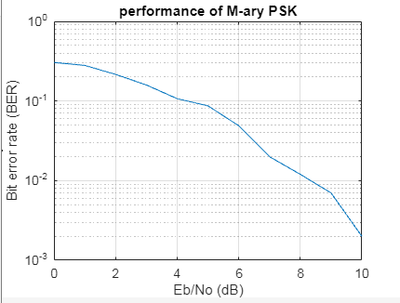

**NAME – Jagdish Padale**

# Experiment No-7

## TE ENTC 39

**TITLE - Simulation Study of Performance of BPSK receiver in presence ofnoise.**

## INPUT:

%transmitterpartc lc;

clear all;close all;

nr_data_bits=8192;b_data=(randn( 1,nr_data_bits))>.5;b=[b_data]; d=zeros(1,length(b));

for n=1:length(b)if(b(n)

==0)d(n)=exp(j*2*pi

);end if(b(n)==1)

d(n)=exp(j*pi); end

enddisp(d

);bpsk=d; figure(1); plot(d,'o');

axis([-22 -22]);

grid on;xlabel("rea l");

ylabel("image");title("BPS Kconstellation");SNR=0:24

; BER1=[];

SNR1=[];

for SNR=0:length(SNR)sigma=sqr t(10.0^(-SNR/10.0));

snbpsk=(real(bpsk)+sigma*randn(size(bpsk)))+i*(imag(bpsk)+sigma*randn(size(bpsk)));

%plottingwithnoisef igure(2);plot(snbpsk

,'o');

axis([-22 -22]);

grid on;xlabel("rea l");

ylabel("image"); title("BPSKconstellationwithnoise");

%recieverr=snbpsk

;bhat=[real(r)<0];b hat=bhat(:);bhat1= bhat;ne=sum(b~=b hat1);

BER=ne/nr_data_bits;BER1=[BER 1 BER];SNR1=[SNR1SNR];

end

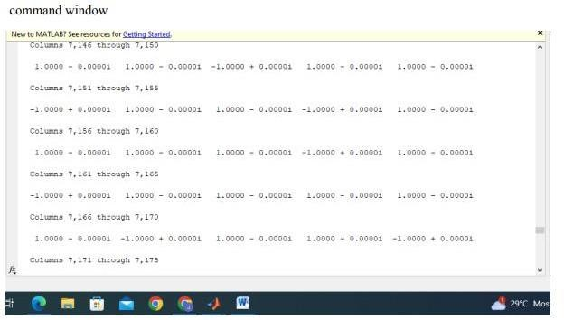

**OUTPUT:**

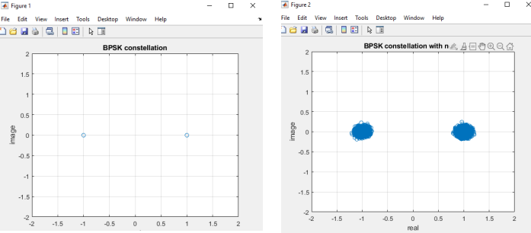

# Experiment No-6

**NAME – Jagdish Padale**

**TE ENTC 39**

## TITLE-

**SimulationStudyofRandomprocesses.Findvariousstaticalparametersofthe random process.**

## INPUT:

%parameter N=1000;t= 1:N;

%genertaterandomprocessx

=randn(1,N);

%statiscal parametresmean_x=mean(x);v ar_x=var(x);autocorr_x=xcorr (x,'biased');

power_spec_density=pwelch(x,[],[],[],1);

%plotting figure;

%plottherandomprocesss ubplot(2,2,1);

plot(t,x); title('Random process');xlabel('Time

index');ylabel('Amplitu de');

%plottheautocorrelationfunctions ubplot(2,2,2);

plot(-(N-1):(N-

1),autocorr_x);title('Autocorrelatio n');

%plot pdssubplot(2,2

,3);

plot(power_spec_density);titl e('powerspectraldensity');xla bel('frequency');ylabel('powe r');

%displaystatisticalparameterd

isp('statisticalparameter')disp( ['mean:' num2str(mean_x)]);disp(['var iance:'num2str(var_x)]);

## OUTPUT:

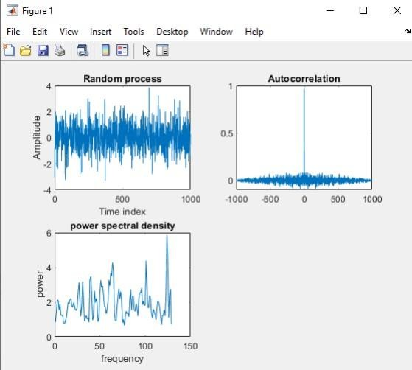

**NAME – Jagdish Padale**

# Experiment No-8

## TE ENTC 39

**TITLE-SimulationStudyofSourceCodingTechnique.**

## INPUT:

clc;code_length

=0;

x=input('Enter no. of symbols:');for m=1:x

symbols(m)=input('enter symbol number:');p(m)=input('enterthe pobability');

endH x=0;

form=1:x

[dict,avglen]=huffmandict(symbols,p); hcode=huffmanenco(m,dict);dsi=huff mandeco(hcode,dict);code_length=le ngth(hcode);Hx=Hx+p(m)*(- log2(p(m)));

enddisp("Entrop y=");disp(Hx);

Efficiency=(Hx/avglen)*100;disp(" Efficiency=");disp(Efficiency);

## OUTPUT:

Enterno.ofsymbols:7 entersymbolnumber: 1

enterthepobability 0.45

entersymbolnumber:

2

enterthepobability 0.15

entersymbolnumber:

3

enterthepobability 0.1

entersymbolnumber:

4

enterthepobability 0.1

entersymbolnumber:

5

enterthepobability 0.08

entersymbolnumber:

6

enterthepobability0

.08

entersymbolnumber:

7

enterthepobability 0.04

Entropy:

2.3621

Efficiency:

98.4210

**NAME – Jagdish Padale**

# Experiment No-9

## TE ENTC 39

**TITLE - Simulation Study of various Entropies and mutual information in acommunicationsystem.**

## INPUT:

clc;

i=input("enter number of elements= ");q=input("entejointprobabilitymatrix=")

;sum=0;

%probability P(x)forn=1:i

w=0;

form=1:i

p(n)=w+q(n,m); w=p(n);

end

end

disp("P(x):"); disp(p);

%entropyH(x) forn=1:i

H=sum+(p(n)*log2(1/p(n)));s um=H;

enddisp('H(x

):');disp(H);

%conditionalprobabilitymatrixf orn=1:i

form=1:i

a(n,m)=q(n,m)/p(n);

end

end

disp('P(Y/X):'); disp(a);

% entropy H(Y/X)d=0;

forn=1:i

form=1:i

if(a(n,m)>0)

H1=d+(q(n,m)*log2(1/a(n,m)));d= H1;

end

end

end

disp('H(Y/X):'); disp(H1);

%mutuLINTERFEENCE(MI) m=H-H1;

disp("MI="); disp(m); forn=1:i

w=0;

form=1:i

s(n)=w+q(m,n); w=s(n);

end

end

disp('P(Y):');

disp(s);

%entropy H(Y)k=0;

forn=1:i

H2=k+(s(n)*log2(1/s(n))); k=H2;

enddisp('H(Y

):');

disp(H2);

## OUTPUT:

EnterThenoofelements=2 Enterjointprobabilitiesmatrix=[0

.450.05;0.1 0.4] P(x):

0.5000 0.5000

H(x):

1

P(Y/X):

0.9000 0.1000

0.2000 0.8000

H(Y/X):

0.5955

M1=

0.4045

P(Y):

0.5500 0.4500

H(Y):

0.9928

**NAME – Jagdish Padale**

# Experiment No-11

## TE ENTC 39

**TITLE – Virtual Lab: QPSK signal generation.INPUT:**

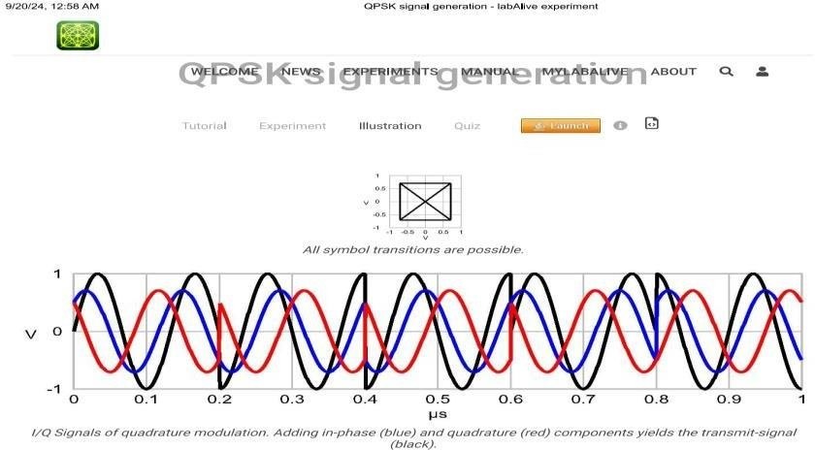

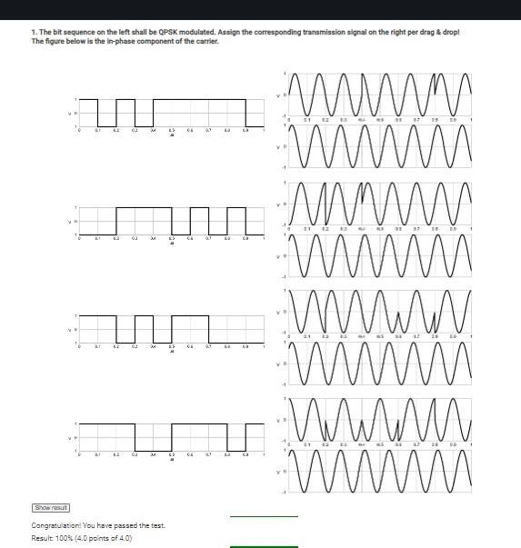

# NAME - Jagdish PadaleExperiment No-12

## TE ENTC 39

**TITLE – Virtual Lab: BPSK modulation and demodulation.INPUT:**

